***Vocational High School***

***of Computer Programming and Innovation***

**Functions with Sets**

**Teamers 1.0:**

*Afra Yusrefova–* [*AFyusrefova18@codingburgas.bg*](mailto:AFyusrefova18@codingburgas.bg)

*Emily Kehayova –* [*EDKehayova18@codingburgas.bg*](mailto:EDKehayova18@codingburgas.bg)

*Kaloqn Dinev –* [*kddinev18@codingburgas.bg*](mailto:kddinev18@codingburgas.bg)

*Reneta Topalska –* [*RBTopalska18@codingburgas.bg*](mailto:RBTopalska18@codingburgas.bg)

*Svetlana Boyadzhieva –* [*SVBoyadzhieva18@codingburgas.bg*](mailto:SVBoyadzhieva18@codingburgas.bg)

## The main goal of the project

The main idea of our project is to make sets more interesting and entertaining rather than boring, help teachers and test our skills which we learnt in our algorithm classes.

## Bock scheme of the code

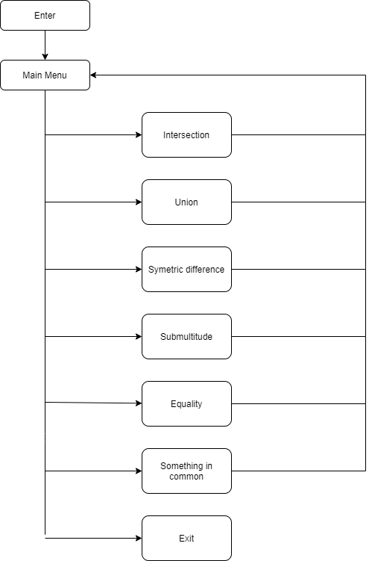

## Functions description

|  |  |  |
| --- | --- | --- |
| Name and type | Purpose | Arguments |
| bool mainMenu | Displays main menu options and performs the corresponding function according to what the user has entered | int sizeOfSetA, int sizeOfSetB, int SetA[], int SetB[] |
| int inputSize | A function that is for entering the size of the set |  |
| void inputSetElements | A function that is for entering the elements of the set | int Set[], int sizeOfSet |
| void findIntersection | A function that finds an intersection between set A and B | int sizeOfSetA, int sizeOfSetB, int SetA[], int SetB[] |
| void findUnion | A function for finding the union between two sets | int sizeOfSetA, int sizeOfSetB, int SetA[], int SetB[] |
| void symetricalDifference | A function that finds symmetric difference between the Sets | int sizeOfSetA, int sizeOfSetB, int SetA[], int SetB[] |
| void isASubSet | a function that will check if there are any sub sets | int sizeOfSetA, int sizeOfSetB, int SetA[], int SetB[] |
| void showIsItEqual | A function that will check if the sets are equal | int sizeOfSetA, int sizeOfSetB, int SetA[], int SetB[] |
| int checkPrime | A function that will check if the set elements are prime numbers | int SetElement |
| void haveSomethingInCommon | a function that shows the user how many odd and even numbers are in each of the sets, what is the sum of every element in the set  and shows the number of prime numbers | int sizeOfSetA, int sizeOfSetB, int SetA[], int SetB[] |

**4. Used technologies:**

The programming language we used to develop our code is C++. We used Teams for communication and for sharing ideas. For development environment we used Visual Studio 2019 and GitHub for collaboration of the team.

**5**. **Future of the project:**

We would like to add an option to work with more than two sets. Other goal of ours is to make the program work with string sets so it can be more functional. Also, we would like to implement the project in unity to make the program interface visually and graphically better and more detailed.

**6. Overview**

In conclusion it is a great experience to be working on this project . During the working process we get to know each other better and it was pleasure to work as a team. We will be glad if we continue developing this project and make it even more helpful for people to use it.